1.Create a table named MusicPlaylist with columns: id, song_name, artist, genre, and duration. Insert at least 5 records representing songs from your favorite Spotify playlist, then write a SELECT statement to retrieve all columns for all songs.

CREATE TABLE MusicPlaylist (
id INT PRIMARY KEY,
song_name VARCHAR(255),
artist VARCHAR(255),
genre VARCHAR(100),
duration INT
);

INSERT INTO MusicPlaylist (id, song_name, artist, genre, duration)
VALUES
(1, 'Shape of You', 'Ed Sheeran', 'Pop', 233),
(2, 'Blinding Lights', 'The Weeknd', 'Synth-pop', 200),
(3, 'Tum Hi Ho', 'Arijit Singh', 'Bollywood', 262),
(4, 'Levitating', 'Dua Lipa', 'Pop', 203),
(5, 'Bohemian Rhapsody', 'Queen', 'Rock', 354);

SELECT * FROM MusicPlaylist;

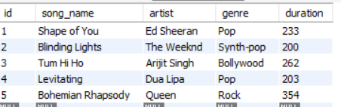

2.Write a SQL query to display only the song_name and artist columns from the MusicPlaylist table, showing just the first 3 records using the LIMIT keyword.

SELECT song_name, artist
FROM MusicPlaylist
LIMIT 3;



3.Suppose you have a table named FoodOrders with columns: id, restaurant, food_item, and order_date. Write a SQL query to list all unique restaurant names where you have placed orders, using the DISTINCT keyword.

SELECT DISTINCT restaurant
FROM FoodOrders;

4.Write a SQL query on the FoodOrders table to select food_item as 'Dish' and order_date as 'Date Ordered', displaying only these two columns with the column aliases in the output.

SELECT food_item AS Dish, order_date AS 'Date Ordered'
FROM FoodOrders;

5.You tried running this query: SELECT DISTINCT food_item, restaurant FROM FoodOrders LIMIT 2, but it returns an error or doesn't work as expected. Identify and fix the mistake in the query.<br><br><em><strong>Hint:</strong> Check the correct placement and usage of the LIMIT keyword in SQL syntax.</em>

SELECT DISTINCT food_item, restaurant
FROM FoodOrders
ORDER BY restaurant ASC
LIMIT 2;

